http://www.ae.illinois.edu/m-selig/ads/aircraft.html lists Sopwith Camel Airfoil as RAF-16.
Source below lists Camel as similar to RAF14, RAF15, RAF16, but most similar to RAF14.
Source: http://www.theaerodrome.com/forum/aircraft/24377-wwi-airfoil-inquiry-2.html
FlyXwire  Forum Ace    Join Date: Feb 2003  Posts: 918 | Hi AJ,  Below is the results of my study of drawings showing the Sopwith Camel's rib shape compared against the NACA templates for the RAF 14, RAF 15, and RAF 16 airfoil profiles. First the Camel's rib from British and German sources (somewhat different):  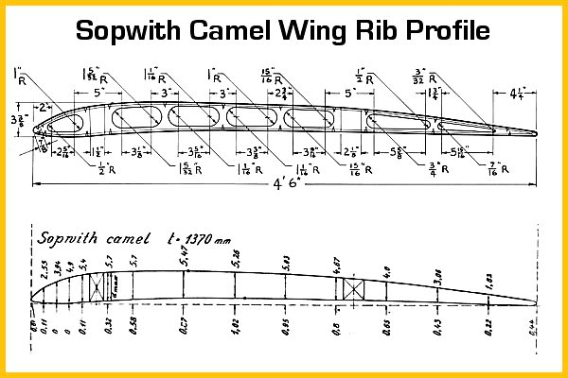  Next, the RAF 14, 15, & 16 sections from the NACA:  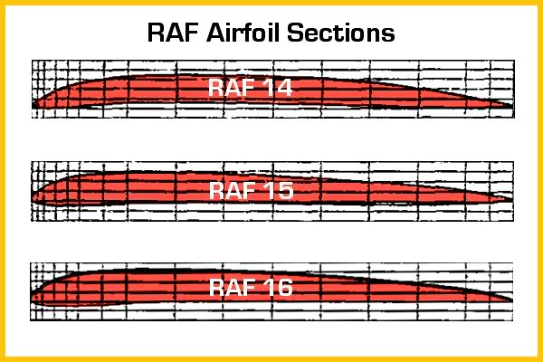  Now the compliance check with the Camel's profile laid over these RAF sections:  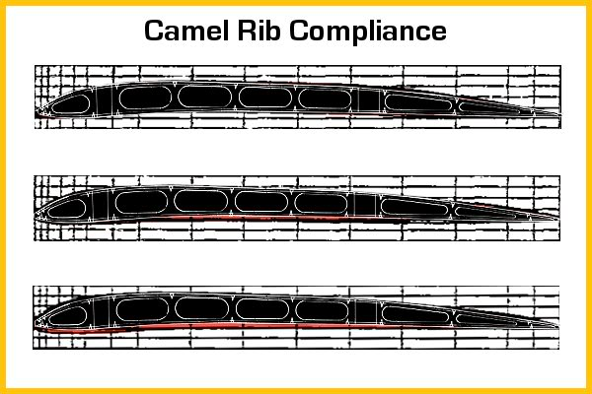  To my eye, of the three survey airfoils shown above, the RAF 14 & 15 come close to matching the Camel's rib shape, with the RAF 14 appearing to be the nearest match. As a further visual check, I used airfoil shapes from the web for comparison, and the RAF 14 seems to match the Camel's rib outline the best:  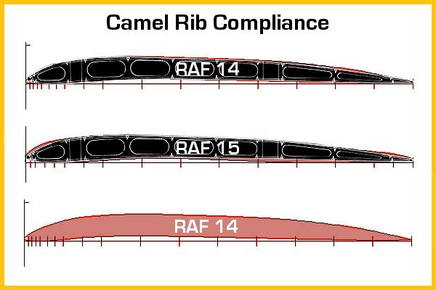  So does this mean that the RAF 14 was the confirmed airfoil used by the Sopwith Camel, not if one's repututation were depending on it, but if one has to make a decision when available information conflicts and resources are limited, devising some method to resolve the issue like the above exercise might prove useful......perhaps.  __________________  Dave S.  "Real aviators are very sharp and not so timorous. That did not help their good relations with the bureaucrats." Willy Coppens
  Click this bar to view the full image.
  Click this bar to view the full image.
  Click this bar to view the full image.
  Click this bar to view the full image.

